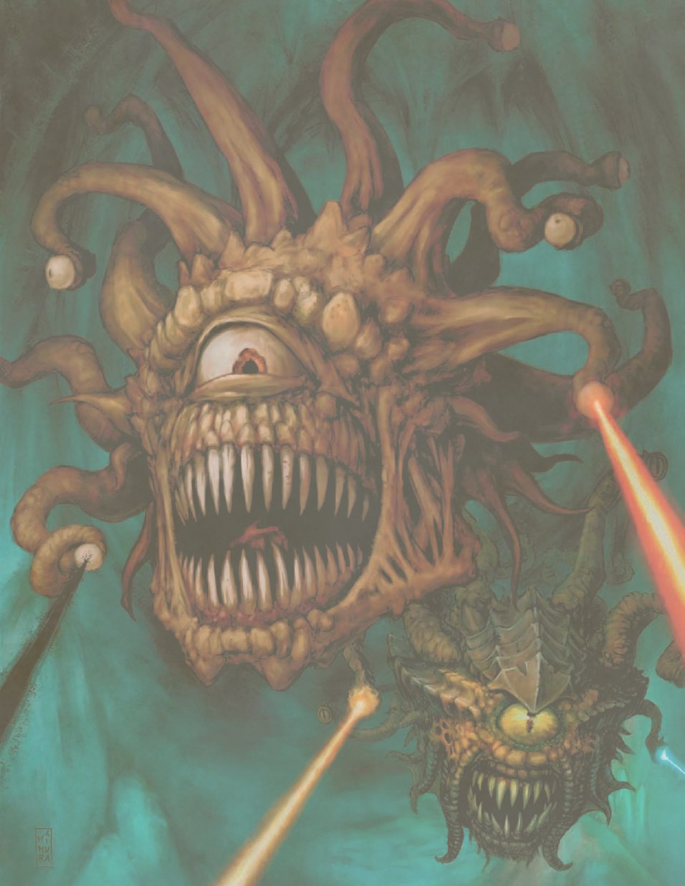

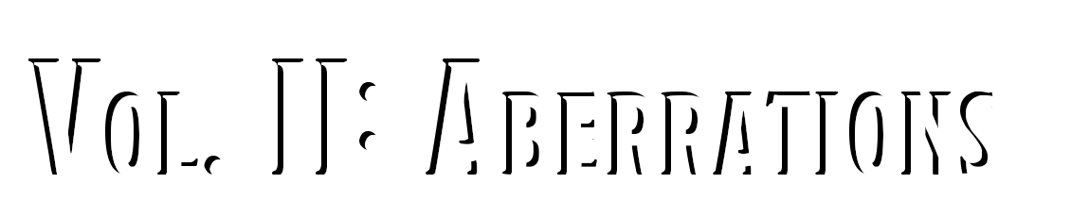





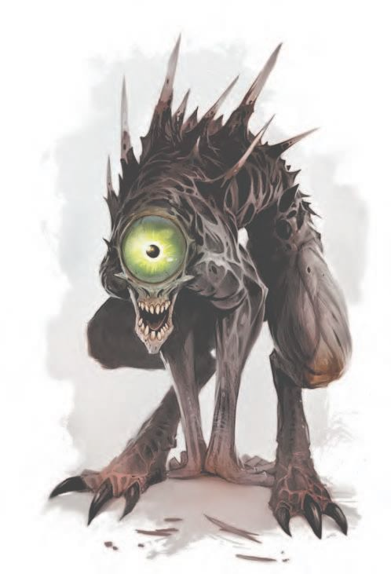

1

INDEX

# Harvest Index, Aberrations

I

have seen them. The large eyes... the gnashing teeth and lashing tentacles. Horrors of the darkness from the realm of madness. I do not know how they get here, but I know they come here to feed. To conquer. To enslave and torture. And that is all I need to know." - Lord Knight Edwin Hylirion

## IntrodUction

DUNGEONS & DRAGONS, D&D, Wizards of the Coast, Forgotten Realms, Ravenloft, Eberron, the dragon ampersand, Ravnica and all other Wizards of the Coast product names, and their respective logos are trademarks of Wizards of the Coast in the USA and other countries.

This work contains material that is copyright Wizards of the Coast and/or other authors. Such material is used with permission under the Community Content Agreement for Dungeon Masters Guild. All other original material in this work is copyright 2019 by D Larson of Paper Druid Publishing and published under the Community Content Agreement for Dungeon Masters Guild.

Thank you for all your support and feedback. Don't forget to leave a rating or review!

If you enjoy this product, keep an eye out for the next Index... Monstrosities!

|  |  |  |  |
| --- | --- | --- | --- |
| Creature Harvest |  | | |
| Creature | Possible Loot | Value (GP) | Use |
| Aboleth | Tail | 4gp | Trophy |
|  | Tentacle | 1gp | Trophy |
|  | Teeth | 6sp | Trophy |
|  | Mucus | 15gp | Practical |
|  | Eyes | 20gp | Practical |
| Balhannoth | Large Hide | 10gp | Trophy, Practical |
|  | Teeth | 1gp | Trophy |
|  | Tail | 3gp | Trophy |
| Beholder | Eye Stalk | 6gp | Trophy, Practical |
|  | Large Eye | 4gp | Trophy, Practical |
|  | Teeth | 1gp | Trophy |
| Berbalang | Wings | 100gp | Trophy |
|  | Teeth | 8sp | Trophy |
|  | Brain Matter | 12gp | Practical |
|  | Claws | 5gp | Trophy |
| Chuul | Claws | 8gp | Trophy |
|  | Large Chitin Fragments | 25gp | Trophy, Practical |
|  | Poison Gland | 2gp | Practical |
| Cloaker | Large Hide | 10gp | Trophy, Practical |
|  | Tail | 4gp | Trophy, Practical |
|  | Teeth | 8sp | Trophy |
| Death Kiss | Blood | 12gp | Practical |
|  | Tentacles | 3gp | Trophy, Practical |
|  | Large Eye | 4gp | Practical |
| Elder Brain | Tentacles | 1gp | Trophy, Practical |
|  | Brain Matter | 8sp | Practical |
| Flumph | Eye Stalk | 1gp | Trophy, Practical |
|  | Tendril | 6sp | Trophy, Practical |



Gauth

Eye Stalk Teeth Medium Eye

4gp 8sp 3gp

Trophy, Practical Trophy

Trophy, Practical

Value (GP) Use

#### Gazer Eye Stalk



Creature Harvest

Beast



Possible Loot

Tiny Eye

#### 1gp 6sp

Trophy, Practical Trophy, Practical

Gibbering Mouther

Teeth Spit

1gp 15gp

Trophy Practical

#### Grell Tentacles

Beak

#### 4gp 2gp

Trophy, Practical Trophy

Intellect Devourer

Claws

**Host Equipment

2gp

---

Trophy

------

#### Ixitxachitl Tail

Fangs

#### 2gp 3sp

Trophy, Practical Trophy

Mind Flayer

Tentacles Skull

3gp 10gp

Practical Practical

#### Mindwitness Teeth

Eye Stalk

#### 1gp 6gp

Trophy

#### Trophy, Practical

Morkoth

Teeth Tentacles

1gp 4gp

Trophy

Trophy, Practical

Neogi Teeth

#### Claws

Small Chitin Fragments

#### 5sp 1gp 3gp

Trophy Trophy

#### Trophy, Practical

Neothelid

Teeth Barbed Tongue

Acid Sac

16gp 25gp 75gp

Trophy

Trophy, Practical Practical

Nothic Large Eye

#### Claws Teeth

4gp 5gp 1gp

#### Trophy, Practical Trophy

Trophy

Otyugh

Teeth Tentacle Large Hide

1gp 6gp 15gp

Trophy

Trophy, Practical Trophy, Practical

#### Slaad, Blue Teeth

Claws Control Gem Large Hide

#### 4gp 25gp 2,000gp

15gp

#### Trophy

Trophy, Practical Practical

#### Trophy, Practical

Slaad, Death

Teeth Claws

Control Gem Medium Hide

10gp 35gp 1,600gp

12gp

Trophy, Practical Trophy, Practical Trophy, Practical Practical

Slaad, Gray Teeth

#### Claws Control Gem Medium Hide

3gp 8gp

#### 1,200gp

12gp

#### Trophy Trophy Practical

Trophy, Practical

Slaad, Green

Teeth Claws

Control Gem Large Hide

4gp 10gp 1,500gp

15gp

Trophy Trophy Practical

Trophy, Practical

#### Slaad, Red Teeth

Claws Control Gem Large Hide

#### 4gp 25gp 1,800gp

15gp

#### Trophy

Trophy, Practical Practical

#### Trophy, Practical

Spectator

Eye Stalk Medium Eye Teeth

4gp 3gp 8sp

Trophy, Practical Trophy, Practical Trophy

Ulitharid Tentacles



INDEX

2

#### Skull

2gp 7gp

#### Trophy, Practical Trophy



An IntrodUction to Skinning

The parts I have listed here are by no means the ONLY parts you can use from a creature, but I have listed the most com- mon and easily sold pieces. Each creature will likely possess some of the following, as described by the table below:

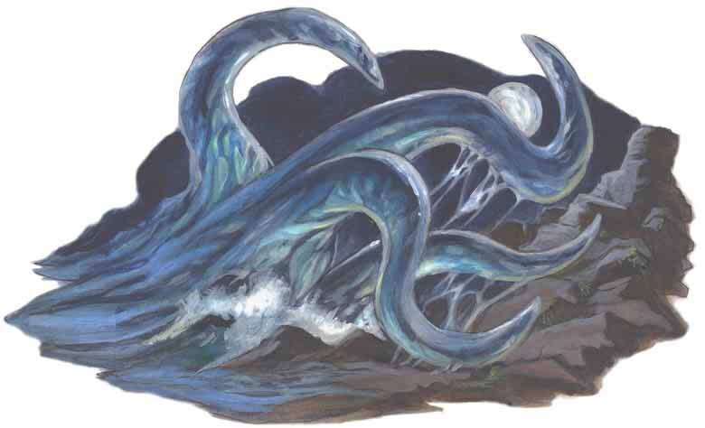

Skinner**'**s Tools

Each toolkit contains a skinning knife, a whetstone, two sets of hempen rope (25 feet long), a flask of oil, 1 lb of salt, and two hunting traps. 25gp

Using the Tools (Survival)

Activity Time Spent DC Skinning tiny & small game 15 Minutes 10 Skinning medium game 45 Minutes 15

Skinning large game 1 Hour 20

Skinning huge game 8 Hours 25

Skinning gargantuan game 1 Week 30

On a successful check, the amount of meat harvested is determined above. The other parts, such as pelts and claws, are also included in these DC checks.

A failed Survival check will result in half the meat being worthless and ruining the pelt or hide in question.

You are proficient with Skinner's Tools if you are proficient with Leatherworker's Tools.

Meat- how much, how to store it, and how much a vendor may pay for it.

Eggs- for applicable creatures, eggs can be eaten or sold as future pets.

Pelts, Skins, and Hides - pelts and hides can be worked into cloaks, bags, or leathers, or sold to vendors.

Claws, Fangs, and Teeth - these parts are typically only used as trophies, but can often be made into jewelry or sold to vendors.

Venom - certain serpents and arachnids (such as scorp- ions and spiders) possess venom glands that can be carefully extracted or bled into containers. This venom can be sold to vendors (as is illegal in many cities) or kept for personal use.



The Harvesting of Meat

I, along with many people scattered across the Planes who know the true nature of aberrant creatures, would highly recommend NOT eating meat from such a monster. That being said, I have provided a random table for those who dare to tempt fate in such a way.

#### Game Size

Tiny 1d4 lbs



Harvestable Meats (lbs)

Small 1d6+10 lbs

Medium 3d10+30 lbs

#### Large 8d10+50 lbs

Huge 12d10+100 lbs



Eating Aberrant Meats



1d20



Effect

1 - 4 The character's flesh becomes corrupted. Over a period of 1d4 hours, the skin spawns painful blisters and large pustules all over the body. The character has disadvantage on all skill checks related to Charisma until the flesh is

cured by a spell such as Lesser Restoration.

5 - 9 After 1d10 minutes, the character finds themselves suffering from the effects of Long-Term Madness, as seen in the table on page 260 of the DMG. These effects last 1d10x10 hours, or until cured with magic, and can range from mild

#### paranoia to a coma-like state that the character cannot be woken from with physical means such as jostling or slapping.



10 -

The character has eaten diseased meat. They must succeed on a DC 15 Constitution saving throw or become

14 infected. If the character fails the saving throw, it takes 1d4 days for the effects to manifest: one level of exhaustion, and regains only half of the hit points usually gained through long rests or Hit Dice. Similar to Sewer Plague, the character must continue to make saving throws (same DC) at the end of each long rest. A failure results in another

level of exhaustion, and a success removes a level. If the character succeeds on removing all levels of exhaustion, they are cured of the disease.

15 -

#### 19

There is no ill effect, though no amount of spice makes the meat enjoyable.





3

HARVESTING TABLES



20 The character is consumed with madness of an indefinite length. Roll on the Indefinite Madness table on page 260 of

the DMG for flaws relating to this madness.

# Practical Parts & How To Use Them

M

any hunters take trophies from their quarry, especially from beasts- but to harvest the organs and extremities from abominations and monsters (and to craft them into something useful or valuable) is another practice altogether.



PRACTICAL USE GUIDE

4



How To Use This GUide

While the following crafting guide is full of ideas and suggestions of my own, I do encourage DMs using this index to embrace the ingenuity of their players and think outside the box! This guide, as all my others, is meant to be the foundation for your own marvelous ideas... and to help your players bring life to theirs.

Brain Matter. While not many studies can be found on the practical uses of aberrant brain matter, certain cabals have delved into the the practice of extracting certain chemicals from fresh brain matter. Depending on the creature, these chemicals can be turned into potions that give the imbiber powers similar to those that the creature originally possessed.

Extracting brain matter properly requires using Alchemy Supplies (DC 18), with which one can then boil down the tissue into a concentrated liquid. This potion, when ingested, will give the imbiber the intended effcts.

Blood. The blood of aberrations is often deadly to those of the Material Plane, consisting of poison or disease. In rare occasions, this life source can be harvested and used as a weapon.

Blood is easily drained from the body and thus requires no check, but it must be stored in a clean glass container to avoid contamination.

Chitin Fragments and Hides. Depending on the size of them, these materials have a variety of practical uses, such as crafting bags and equipment, armor, eating utens- ils, etc.

Chitin makes for a decent carapace shield, as it is lighter than most metals but often just as durable. Harvesting a big enough piece in good enough condition to create such a shield will require 1 hour and a Survival check (DC 15).

Eyes & Eye Stalks. These parts expire rapidly once the aberration has died, so properly storing them in jars of salt water as soon as possible is crucial. They have a small variety of unique uses, mostly for those interested in their magical properties. The eye stalks of Beholders and other similar creatures can be magically preserved into either wands (Arcana check, DC 18) or arcane focuses (Arcana check, DC 15).

These wands are capable of casting one of the creature's eye beam attacks 1d4 times per long rest. The type of beam that the wand can cast should be decided by the DM as it is being crafted.

Turning the main eye into a focus is much harder, as it must be magically shrunk to easily fit in one's hand. This will require 1d4 days of work, and a new Arcana check (DC 15) after each long rest, but will yield a +1 arcane focus if all DCs are met properly.

Tongues, Tentacles, and Tails. Much like the hides of these creatures, the usefulness of these extremities is dependent on their size. The tail can be whittled down using Leatherworker's Tools (DC 15) and crafted into a Barbed Whip (see Cloaker). This is true for the tails of all aberrations listed in the index, unless otherwise stated in the creature details below.

## Aboleth (CR 10)

These creatures resemble a bizarre eel, with long, tubular bodies, as well as a tail at one end and two fins near the head, where one will find a large, jawless mouth full of serrated teeth.



Potion of the Aberrant Gaze

Part Requirement: Aboleth Eyes. (DC 16)

Once the eyes have been melted down into a liquid, this potion is a thick salmon color, and tastes absolutely awful.

Effect. Within a minute of ingesting the concoction, the imbiber will gain the following ability for 1d4 hours:

You can target one creature you can see within 30 ft. of you and fix your gaze upon it. The target must succeed on a DC 14 Wisdom saving throw or be magically Charmed until the you die or until you are on a different plane of existence from the target.

The Charmed target is under your control and can't take reactions, and both you and the target can communicate telepathically with each other over any distance.

Whenever the Charmed target takes damage, the target can repeat the saving throw. On a success, the effect ends. If the target ends up over 1 mile away from you, it may then also repeat the saving throw.

Cost. 150gp



bane of the Aboleth Potion

Part Requirement: An aboleth's body secretes a thick mucus that can very carefully extracted from the skin using Alchemy Supplies (DC 15) and put into glass vials. On a failed DC, the character must make the Constitution saving throw or contr- act the disease themselves.

Effect. The mucus works as a poison- if ingested, the imbiber must succeed on a DC 14 Constitution saving throw or become diseased. After 1 minute, the diseased's skin becomes translucent and slimy, and they can't regain Hit Points unless underwater.

The disease can be removed only by a disease-curing spell of 6th level or higher. When they are outside a body of water, they take 1d12 acid damage every 10 minutes- unless moisture is applied to the skin before the 10 minutes have passed.

Cost. 800gp

## beholder (CR 13)



5

PRACTICAL USE GUIDE

Among the most basic of the Beholder's abilities are their deadly ability to project magical power from their eyes, in varying forms such as instilling fear within, charming, knocking out, petrifying, disintegrating, slowing, or killing their enemies.



The Eye of the beholder

Part Required: The large, central eye of a beholder or similar creature.

Once delicately removed, this eye can be shrunken down and combined with glass or crystal to perfectly preserve the eye inside. This requires at least 8 hours and a successful Arcana check (DC 18).

While wielding the eye, the following effects are maintain- ed:

The eye acts as a +1 arcane focus that increases your spell damage and your spell attack bonus by 1.

An unsettling feeling of being watched overwhelms every- one within 30ft of the eye. Long rests require an extra hour due to the paranoia.

When in complete darkness, the eye grants its wielder darkvision up to 60ft.

Cost. 1,650gp



Stalk Wand

Parts Required: Any eye stalk of a beholder or similar creature, a bone from any creature.

This wand is made by winding a severed eye stalk around a clean bone and preserving it that way for at least 3 days. The bone serves as a handle and the wielder can point the eye at their enemies.

Effect. Each wand made this way is capable of any of the eye rays that a beholder may use when alive, but the wielder does not get to choose the type of ray that is used.

At the beginning of each day, the wand has 1d4 charges, and any unused charges fade after the 24 hours is up. Every time the wand is used, the player (or DM) can roll on the table below:

#### 



d10



Eye Ray Type

1 Charm

2 Paralyzing

3 Fear

#### 4 Slowing

5 Enervation

6 Telekinetic

7 Sleep

#### 8 Petrification

9 Disintegration

10 Death

The wand may hold multiple charges of the same ray type, the exception being the death ray. The ray types deal damage as described below:

Charm Ray. The targeted creature must succeed on a DC 16 Wisdom saving throw or be charmed by the wielder for

1 hour, or until the wielder (or their allies) harms the creature.

Paralyzing Ray. The targeted creature must succeed on a DC 16 Constitution saving throw or be paralyzed for 1 minute. The target can repeat the saving throw at the end of each of its turns, ending the effect on itself on a success.

Fear Ray. The targeted creature must succeed on a DC 16 Wisdom saving throw or be frightened for 1 minute. The target can repeat the saving throw at the end of each of its turns, ending the effect on itself on a success.

Slowing Ray. The targeted creature must succeed on a DC 16 Dexterity saving throw. On a failed save, the target’s speed is halved for 1 minute. In addition, the creature can’t take reactions, and it can take either an action or a bonus action on its turn, not both. The creature can repeat the saving throw at the end of each of its turns, ending the effect on itself on a success.

Enervation Ray. The targeted creature must make a DC 16 Constitution saving throw, taking 5d8 necrotic damage on a failed save, or half as much damage on a successful one.

Telekinetic Ray. If the target is a creature, it must succ- eed on a DC 16 Strength saving throw or the wielder can move it up to 30 ft. in any direction. It is restrained by the ray’s telekinetic grip until the start of the wielder’s next turn or until the wielder is incapacitated. If the target is an object weighing 200 pounds or less that isn’t being worn or carried, it is moved up to 30 ft. in any direction. The wielder can also exert fine control on objects with this ray, such as manipulating a simple tool or opening a door or a container.

Sleep Ray. The targeted creature must succeed on a DC 16 Wisdom saving throw or fall asleep and remain unconscious for 1 minute. The target awakens if it takes damage or another creature takes an action to wake it. This ray has no effect on constructs and undead.

Petrification Ray. The targeted creature must make a DC 16 Dexterity saving throw. On a failed save, the creature begins to turn to stone and is restrained. It must repeat the saving throw at the end of its next turn. On a success, the effect ends. On a failure, the creature is petrified until freed by the greater restoration spell or other magic.

Disintegration Ray. If the target is a creature, it must succeed on a DC 16 Dexterity saving throw or take 6d8 force damage. If this damage reduces the creature to 0 hit points, its body becomes a pile of fine gray dust.

If the target is a Large or smaller nonmagical object or creation of magical force, it is disintegrated without a saving throw. If the target is a Huge or larger object or creation of magical force, this ray disintegrates a 10-foot cube of it.

Death Ray. The targeted creature must succeed on a DC 16 Dexterity saving throw or take 6d10 necrotic damage. The target dies if the ray reduces it to 0 hit points.

Cost. 2,800gp

## berbalang (CR 2)

A berbalang is a rare, winged humanoid with needle-like teeth and razor sharp claws. It is a creature that is rarely seen due to the fact that it doesn't spend most of its time in the Material Plane.



Potion of TrUesight

Part Required: Brain matter from a Berbalang.

Effect. Once reduced to liquid and consumed, this potion grants the drinker truesight for 1d6 hours.

Out to 120 ft, the one who consumes this potion can see in normal and magical darkness, see invisible creatures and objects, automatically detect visual illusions and succeed on saving throws against them, and perceive the original form of a shapechanger or a creature that is transformed by magic. Furthermore, the drinker can see into the Ethereal Plane within the same range.

Cost. 425gp

## ChUUl (CR 4)

A horrible mix of crustacean, insect, and serpent, the chuul is an abomination that lurks submerged or partially submerged, awaiting intelligent prey to devour.

so as to make it impossible to track which is the real one. If the cloak-wearer is ever in an area of bright light, the duplicates disappear.

Whenever any creature targets the wearer with an Attack or a harmful spell while a duplicate remains, that creature rolls randomly to determine whether it truly targets the wearer or one of the duplicates. A creature is unaffected by this magical effect if it can't see or if it relies on senses other than sight.

A duplicate has the cloaker's AC and uses its saving throws. If an Attack hits a duplicate, or if a duplicate fails a saving throw against an effect that deals damage, the duplicate disappears.

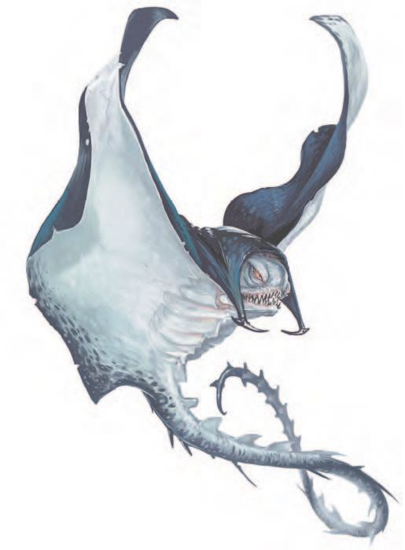

Cost. 1,100gp



Carapace Shield

Part Required: Large chitin fragment, relatively undamaged.

When a proper handle is attached to the chitin, it can make for a light and durable shield.

Shield AC: 3

Weight: 3lbs Cost. 125gp



Paralyzing Poison

Part Required: Poison gland from an applicable creature



PRACTICAL USE GUIDE

6

which must be extracted with Poisoner's Kit (DC 16). One need only come into contact with this poison, so even in its creation one must be extremely careful. Because of this caution, it takes a full 8 hours to extract and store this poison properly.

Effect. Once a creature comes into contact with the poison, they must succeed on a DC 16 Constitution saving throw or be Poisoned for 1 minute. Until this poison ends, the target is Paralyzed. The target can repeat the saving throw at the end of each of its turns, ending the effect on itself on a success.

Cost. 275gp

## Cloaker (CR 8)

Named for its uncanny resemblance to a regular black cloak, the Cloaker's hide makes an excellent material with which to craft an actual cloak.



Shadow Cloak

Parts Required: Cloaker Hide (DC 18), Cloaker Claw This cloak is sleek and black, and clasped together by the

cloaker's claw. It gives its wearer the Phantasm ability used by Cloakers once per long rest:

The wearer magically creates three illusory duplicates of themselves if they aren't in bright light. The duplicates move with the wearer and mimic his/her Actions, shifting position

### barbed Whip

Parts Required: Tail (DC 13)

When attached to a proper handle, the sharp tail of a cloaker makes a brutal weapon.

Martial Melee Weapon Damage: 1d6 Slashing Properties: Finesse, Reach (10ft) Weight: 4lbs

Cost. 40gp

## Death Kiss (CR 10)

As with most of the lesser beholders, the Death Kiss was spawned as a physical manifestation from a beholder's vivid dream. A death kiss has tentacles that end in mouths instead of eyestalks.



Vial of Lightning blood

Parts Required: Blood, carefully drained using Alchemy Supplies (DC 18). A failed check results in the harvester taking 1d10 lightning damage.

Effect. When this blood comes into contact with a creature, they take 1d10 lightning damage. The vial can be thrown and shattered upon an enemy, or opened and splashed upon for the same effect.

Bonus. If your DM allows, the blood may also be carefully

coated onto 1d6 arrows. Any enemies struck with these arrows take an additional 1d8 lightning damage.

Cost. 100gp



Kiss of Death

Parts Required: Tentacle (DC 13)

When attached to a proper handle, the draining tentacles of the Death Kiss can be made into a durable whip that, when grappling an enemy, can drain the blood from them and funnel that life source back into its wielder.

Martial Melee Weapon Damage: 1d6 Slashing

Grapple Effect: Once per long rest, when the player wield- ing the whip succeeds on an attack roll, the target must make a DC 16 Dexterity saving throw or be grappled by the whip. Once grappled, they must succeed on a DC 16 Constitution saving throw or take 2d10 lightning damage, and the wielder regains half as many hit points.

Properties: Finesse, Reach (10ft) Weight: 3lbs

Cost. 600gp

## Elder brain (CR 14)

An elder brain was the final stage of the mind flayer life cycle. Although its intellect was of godlike proportions, its only physical attack was by using its tendrils to lash out at or grapple an opponent.



Poison of Psychic Affliction

Parts Required: Brain matter of an Elder Brain

The briny juices that coat the deep crevices of this creature can be extracted using Alchemy Supplies (DC 15) and stored in glass vials.

Effect. This potent secretion attacks the mind of its imbiber. The target must succeed on a DC 18 Intelligence saving throw or take 5d10 psychic damage and be stunned for 10 minutes. A target can repeat the saving throw at the end of each of its turns, ending the effect on itself on a success.

Cost. 730gp

business. Their name comes from the sound they make while moving through the air.



Stench bomb

Parts Required: Stench Gland (DC 16)

Once removed, the stench gland of a flumph can be emptied into glass vials for later use. However, while doing this, the harvester will be victim to the stench and have to make a Constitution saving throw (DC 15) or become poisoned for 1d4 hours unless wearing a mask.

Effect. A vial of this grotesque liquid can be thrown or poured somewhere to release the noxious fumes. If thrown at a creature, the target exudes a horrible stench for 1d4 hours. The coated creature is poisoned as long as the stench lasts, and other creatures are poisoned while with in 5 feet of the coated creature. A creature can remove the stench on itself by using a short rest to bathe in water, alcohol, or vinegar.

If the vial is thrown or poured upon the ground, every creature within 5 feet of the liquid is poisoned until they move out of range of the stench.

Cost. 60gp

## GaUth (CR 6)

Known as a lesser beholder, the Gauth is a similarly shaped creature that feeds off of magic and wealth.



Lesser Stalk Wand

Parts Required: Any eye stalk of a Gauth or similar creature, a bone from any creature.

This wand is made by winding a severed eye stalk around a clean bone and preserving it that way for at least 3 days. The bone serves as a handle and the wielder can point the eye at their enemies.

Effect. Each wand made this way is capable of any of the eye rays that a gauth may use when alive, but the wielder does not get to choose the type of ray that is used.

At the beginning of each day, the wand has 1d4 charges, and any unused charges fade after the 24 hours is up. Every time the wand is used, the player (or DM) can roll on the table below:

#### 



brain Link CUffs



d6



Eye Ray Type

Parts Required: Tendril of an Elder Brain, which must be



PRACTICAL USE GUIDE

7

severed at its root. When dried and cured properly (over a 3 day period), this tendril becomes fibrous, like thin rope.

Effect. This tendril is used to bind together your wrist and that of a target creature that is incapacitated. Once bound, you have a psychic link to the target for one hour. You gain insight into the target’s reasoning, emotional state, and thoughts in its mind (including things the target worries about, loves, or hates), and can do this once per long rest.

You can also make a Charisma (Deception) check with advantage to deceive the target’s mind into thinking it believes an idea or feels a particular emotion. The target contests this attempt with a Wisdom (Insight) check. If you succeed, the target mind believes the deception for 1 hour or until evidence of the lie is presented to the target.

Cost. 1,450gp

## FlUmph (CR 1/8)

These benevolent creatures spend their time floating around the underdark, avoiding evil creatures and minding their own

#### 2 Enervation

1 Devour Magic

3 Pushing

4 Fire

5 Paralyzing

#### 6 Sleep

The wand may not hold multiple charges of the same ray type. The ray types have the effects described below:

Devour Magic Ray: The targeted creature must succeed on a DC 14 Dexterity saving throw or have one of its magic items lose all magical properties until the start of your next turn. If the object is a charged item, it also loses 1d4 charges. Determine the affected item randomly, ignoring single-use items such as potions and scrolls.

Enervation Ray: The targeted creature must make a DC 14 Constitution saving throw, taking 3d8 necrotic damage

on a failed save, or half as much damage on a successful one.

Pushing Ray: The targeted creature must succeed on a DC 14 Strength saving throw or be pushed up to 15 feet directly away from you and have its speed halved until the start of your next turn.

Fire Ray: The targeted creature must succeed on a DC 14 Dexterity saving throw or take 3d10 fire damage.

Paralyzing Ray: The targeted creature must succeed on a DC 14 Constitution saving throw or be paralyzed for 1 minute. The target can repeat the saving throw at the end of each of its turns, ending the effect on itself on a success.

Sleep Ray: The targeted creature must succeed on a DC 14 Wisdom saving throw or fall asleep and remain unconscious for 1 minute. The target awakens if it takes damage or another creature takes an action to wake it. This ray has no effect on constructs and undead.

Cost. 2,100gp

## Gazer (CR 1/2)

A gazer is "born" out of a beholder's feverish dreams in which its perception of scale and perspective was warped by its delirium. It is often found following its creator like a pet.



Minor Stalk Wand

Parts Required: Eye Stalk of a Gazer, a leg bone from a small-sized creature.

This wand is made by winding a severed eye stalk around a clean bone and preserving it that way for at least 3 days. The bone serves as a handle and the wielder can point the eye at their enemies.

Effect. Each wand made this way is capable of any of the eye rays that a gazer may use when alive, but the wielder does not get to choose the type of ray that is used.

At the beginning of each day, the wand has 2 charges, and any unused charges fade after the 24 hours is up. Every time the wand is used, the player (or DM) can roll on the table below:

Telekinetic Ray: If the target is a creature that is Medium or smaller, it must succeed on a DC 12 Strength saving throw or be moved up to 30 feet directly away from you.

## Gibbering MoUther (CR 2)

These abominations are unnatural aberrations, nightmarish blobs of mouths and eyes favored by the drow god Ghauna- daur.



Flash bomb

Parts Required: Spit from a Gibbering Mouther.

This requires extraction with Alchemy Supplies (DC 15), and can be stored in glass vials, as with most aberrant chemicals.

Effect. Much like the Stench Bomb, the Flash Bomb is best used when thrown in its vial. The chemical glob inside explodes in a blinding flash of light on impact, and each creature within 5 feet of the flash must succeed on a DC 15 Dexterity saving throw or be Blinded until the end of your next turn.

Cost. 80gp

## Grell (CR 3)

Grell have two priorities: colonize new lands and feed. Although instinct alone drives a grell to reproduce, feed, and expand their territory, their intelligence allow them to plan their actions far better than any pack of wild predatory animals could.

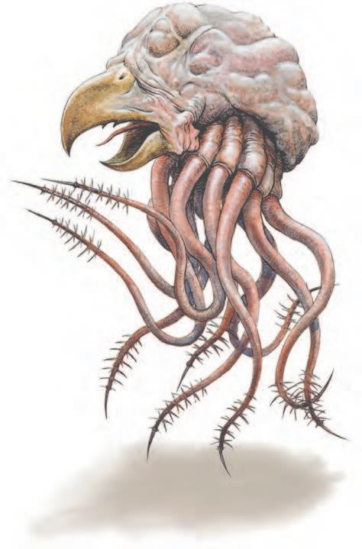

#### 



d4



Eye Ray Type

1 Dazing

2 Fear

3 Frost

#### 4 Telekinetic



PRACTICAL USE GUIDE

8

The wand may not hold multiple charges of the same ray type. The ray types have the effects described below:

Dazing Ray: The targeted creature must succeed on a DC 12 Wisdom saving throw or be charmed until the start of your next turn. While the target is charmed in this way, its speed is halved, and it has disadvantage on attack rolls.

Fear Ray: The targeted creature must succeed on a DC 12 Wisdom saving throw or be frightened until the start of your next turn.

Frost Ray: The targeted creature must succeed on a DC 12 Dexterity saving throw or take 2d6 cold damage.

Poison Whip

Parts Required: Tentacle (DC 12)

When attached to a proper handle, the barbed tentacle of a grell makes a weapon capable of poisoning its targets.

Martial Melee Weapon

Damage: 1d6 Piercing. The target must succeed on a DC 11 Constitution saving throw or be poisoned for 1 minute. The poisoned target is paralyzed, and it can repeat the saving throw at the end of each of its turns, ending the effect on a success.

Properties: Finesse, Reach (10ft) Weight: 4lbs

Cost. 60gp



Potion of Lightning Resistance

Parts Required: Tentacle Barbs (DC 14)

If the character fails the DC check to safely remove the barbs, they suffer 1d6 poison damage. Once removed, the barbs can be crushed into a fine powder with a mortar and pestle.

Effect. This powder, when added to purified water in a glass vial, grants its imbiber resistance to lightning damage for 1 hour.

Cost. 200gp

## Intellect DevoUrer (CR 2)

The intellect devourer resembles a walking brain protected by a crusty covering and set on bestial clawed legs. This foul aberration feeds on the intelligence of other creatures.

Host Equipment. This creature is a body thief- one of the intellect devourer's abilities is to magically consume the brain of an incapacitated creature and then teleport inside their head to take control of it. However, once the host body dies, it has no choice but to retain its natural form.

In this instance, you would be able to harvest from both creatures- aside from the brain matter of the host, of course.

## Ixitxachitl (CR 1/4)

Also known as demon ray, the Ixitxachitl is an aquatic creature resembling a manta ray. They are evil servants of Demogorgon that dwell in the ocean.



barbed Whip

preserving it that way for at least 3 days. The bone serves as a handle and the wielder can point the eye at their enemies.

Effect. Each wand made this way is capable of any of the eye rays that a gauth may use when alive, but the wielder does not get to choose the type of ray that is used.

At the beginning of each day, the wand has 1d4 charges, and any unused charges fade after the 24 hours is up. Every time the wand is used, the player (or DM) can roll on the table below:

#### 



d6



Eye Ray Type

1 Aversion

2 Fear

3 Psychic

#### 4 Slowing

5 Stunning

6 Telekinetic

The wand may not hold multiple charges of the same ray type. The ray types have the effects described below:

Aversion Ray: The targeted creature must make a DC 13 Charisma saving throw. On a failed save, the target has disadvantage on attack rolls for 1 minute. The target can repeat the saving throw at the end of each of its turns, ending the effect on itself on a success.





9

PRACTICAL USE GUIDE

Like the Cloaker, the Ixitxachitl's tail makes an excellent whip.

## Mind Flayer (CR 7)

Mind flayers are tyrants, slavers, and planar voyagers. They view themselves as masterminds, controlling, harvesting, and twisting the potential of other creatures to further their evil and far-reaching goals.



Poison of Lesser Psychic Affliction

Parts Required: Tentacle (DC 13) While not as potent as the psychic energy that secretes from the Elder Brain, all illithid possess a fraction of it.

This poison is crafted the same way as the Poison of Psychic Affliction, but requires the juices of the tentacles instead of the brain matter.

Effect. This chemical attacks the mind of its imbiber. The target must succeed on a DC 15 Intelligence saving throw or take 4d8 psychic damage and be stunned for 10 minutes. A target can repeat the saving throw at the end of each of its turns, ending the effect on itself on a success.

Cost. 180gp

## Mindwitness (CR 5)

Mindwitnesses are flying nightmares of eyes and tentacles created by mind flayers by inserting one of their tadpoles into a beholder.



Wand of the Witness

Parts Required: Any eye stalk of a Mindwitness or similar creature, a bone from any creature. This wand is made by winding a severed eye stalk around a clean bone and

Fear Ray: The targeted creature must succeed on a DC 13 Wisdom saving throw or be frightened for 1 minute. The target can repeat the saving throw at the end of each of its turns, ending the effect on itself on a success.

Psychic Ray: The target must succeed on a DC 13 Intelligence saving throw or take 4d8 psychic damage.

Slowing Ray: The targeted creature must make a DC 13 Dexterity saving throw. On a failed save, the target’s speed is halved for 1 minute. In addition, the creature can’t take reactions, and it can take either an action or a bonus action on its turn but not both. The creature can repeat the saving throw at the end of each of its turns, ending the effect on itself on a success.

Stunning Ray: The targeted creature must succeed on a DC 13 Constitution saving throw or be stunned for 1 minute. The target can repeat the saving throw at the start of each of its turns, ending the effect on itself on a success.

Telekinetic Ray: If the target is a creature, it must make a DC 13 Strength saving throw. On a failed save, you moves it up to 30 feet in any direction, and it is restrained by the ray’s telekinetic grip until the start of your next turn or until you are incapacitated.

## Morkoth (CR 11)

These creatures are also known as wraiths of the deep, a cruel and evil race of aquatic predators with hypnotic powers.



Hypnotic Poison

Parts Required: Tentacle, ground and juiced. The hypnotic

chemical is minute and is easily tarnished by damaging the tentacle. Therefore more than one tentacle is typically need- ed for a dose of the poison.



PRACTICAL USE GUIDE

10

Effect. The creature that ingests this poison must make a DC 17 Wisdom saving throw. On a failed save, the creature is charmed for 10 minutes by the first person who speaks to it and becomes highly suggestible, as though under the effects of the Suggestion spell.

When the hypnosis wears off, the creature will remember what it did, but will not know it was charmed or hypnotized. Cost. 700gp

## Neogi (CR 3)

Neogi are small eight-legged creatures, the adults no bigger than a small child. They have a head with reflective eyes that sit upon a long eel-like neck. With their hairy flattened abdomen, they are sometimes described as akin to a cross between a wolf spider and an eel.



Small Chitin Fragments

These fragments are often too small to craft anything out of, but in some desert regions chitin is ground into a fine powder and then mixed with water and clay in order to form a sort of cementing paste for use in construction.

## Neothelid (CR 13)

Neothelids are the gargantuan result of a failed illithid colony, making them extremely rare creatures. A tadpole that evolved in the exact conditions and then survived the chaos of the abandoned spawning pools becomes a giant, acid-spewing worm



barbed Whip

The Neothelid's barbed tongues are similar to the Cloaker and Ixitxachitl's tails, and can be crafting into a Barbed Whip in the same fashion.



Acid bomb

Parts Required: Acid Sac, extracted carefully with Alchemy Supplies (DC 18).

The acid sac must be extracted whole. A failed check destroys the sac and causes the harvester to take 2d6 acid damage.

Effect. Once removed, the acid sac makes for a great trap, but is highly flammable and must be handled with caution. When the sac is ignited, it explodes with a blast radius of 20 feet, and every creature in the area must make a Dexterity saving throw (DC 18) or take 6d6 acid damage.

Cost. 625gp

## Nothic (CR 2)

Nothics are the result of a curse befalling wizards who delved too deep into arcane knowledge. Once transformed, the nothic holds no discernible memory of its former self, except for a faint notion that there might be a way to reverse its condition.



FocUs of Weird Insight

Parts Required: Eye of a Nothic (DC 16)

Once delicately removed, this eye can be shrunken down and combined with glass or crystal to perfectly preserve the eye

inside. This requires at least 8 hours and a successful Arcana check (DC 18).

While wielding the eye, the following effects are maintain- ed:

The eye acts as an arcane focus that gives its wielder Keen Sight. This grants advantage on Wisdom (Perception) checks that rely on sight when the Focus is in hand.

Once per day, you can target one creature you can see within 30 ft. of it. The target must contest its Charisma (Deception) check against your Wisdom (Insight) check. If you win, you magically learn one fact or secret about the target. The target automatically wins if it is immune to being charmed.

Cost. 950gp

## OtyUgh (CR 5)

Otyughs are primarily omnivorous scavengers. They can consume almost all kinds of refuse and waste, such as carrion, offal, and many other things others would view as garbage. Nevertheless, they will take fresh meat when they have the chance.



Aberrant Hide Satchel

Parts Required: Medium or Large Hide from an aberrant creature, 5gp worth of metal hardware such as buckles and clasps.

Crafting. Once the creature has been skinned, the hide must be treated using Leatherworker's Tools with a DC of 12, and then cut and formed into its satchel shape. A final DC of 18 will yield a well-crafted satchel capable of holding one cubic foot or 50 lbs of gear. This entire process takes a min- imum of 8 hours a day, for 3 days to complete.

Cost. 120gp



Vial of Filth Fever

Parts Required: Saliva of an Otyugh (DC 12)

Due to the nature of their appetites, the mouth of an otyugh is often disgusting and diseased. This can be used to the harves- ter's advantage. The saliva can be placed in vials and used in a variety of ways, but the most common ways are placing the liquid into someone's food or drink, or smearing it onto a weapon so the disease is introduced to the bloodstream.

Effect. When the disease is introduced into a target creature's system, they must succeed on a DC 15 Constitution saving throw against disease or become Poisoned until the disease is cured.

Every 24 hours that elapse, the target must repeat the saving throw, reducing its hit point maximum by 1d10 on a failure. The disease is cured on a success. The target dies if the disease reduces its hit point maximum to 0. This reduction to the target's hit point maximum lasts until the disease is cured.

Cost. 275gp

## Slaad, blUe (CR 7)

Their base form was that of a large bipedal frog, though some of the more powerful slaadi had polymorph self or shape- change abilities and sometimes appeared as humanoids.

Blue Slaadi are born from the eggs that Red Slaadi put into humanoid hosts, who are then eaten from the inside out by

the growing tadpole.



Dagger of Disease

Parts Required: The foreclaws of a Blue Saad, carefully removed and attached to a hilt. (DC 10) A failure results in the harvester having to succeed on the Consitution saving throw or become diseased.

Simple Melee Weapon Damage: 1d6 Piercing

Properties: Finesse, Light, Range, Thrown (20/60ft) Weight: 1 lb

Effect. If the target struck by the dagger is a humanoid, it must succeed on a DC 15 Constitution saving throw or be infected with a disease called chaos phage. While infected, the target can’t regain hit points, and its hit point maximum is reduced by 1d6 every 24 hours.

If the disease reduces the target’s hit point maximum to 0, the target instantly transforms into a red slaad or, if it has the ability to cast spells of 3rd level or higher, a green slaad. Only a wish spell can reverse the transformation.

Cost. 930gp



Variant: Control Gem

See the Control Gem passage at the end of the guide.

## Slaad, Death (CR 10)

Death slaadi emerged as the result of a gray slaad having devoured the corpse of a dead death slaad. As their previous form, they could wield greatswords and imbue them with their own magic.



Necrosis Knife

Parts Required: The foreclaws of a Death Slaad, carefully removed and attached to a hilt. (DC 10) A failure results in the harvester taking 1d6 necrotic damage.

Simple Melee Weapon Damage: 1d6 Necrotic

Properties: Finesse, Light, Range, Thrown (20/60ft) Weight: 1 lb

Cost. 280gp



Variant: Control Gem

See the Control Gem passage at the end of the guide.

## Slaad, Red (CR 5)

Red slaadi appear as the result of the chaos phage disease that infects humanoids by contact with blue slaadi hooks, and are the slaadi egg-bearers.



Dagger of Slaadi Fertility

Parts Required: The foreclaws of a Red Slaad, carefully removed and attached to a hilt. (DC 13) A failure results in the harvester having to succeed on a DC 14 Constitution saving throw in order to avoid getting infected with an imperceptible slaad egg.

Simple Melee Weapon Damage: 1d6 Piercing

Properties: Finesse, Light, Range, Thrown (20/60ft) Weight: 1 lb

Cost. 675gp

If the harvested slaad infected no one during the initial combat, then the dagger has the following effect:

Effect. If the target is a humanoid, it must succeed on a DC 14 Constitution saving throw or be infected with a disease - a minuscule slaad egg. Each dagger crafted has the ability to infect a host with one egg.

A humanoid host can carry only one slaad egg to term at a time. Over three months, the egg moves to the chest cavity, gestates, and forms a slaad tadpole. In the 24-hour period before giving birth, the host starts to feel unwell, its speed is halved, and it has disadvantage on attack rolls, ability checks, and saving throws. At birth, the tadpole chews its way through vital organs and out of the host’s chest in 1 round, killing the host in the process.

If the disease is cured before the tadpole’s emergence, the unborn slaad is disintegrated.





11

PRACTICAL USE GUIDE



Variant: Control Gem

See the Control Gem passage at the end of the guide.

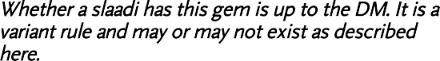

Variant: Control Gem

*Whether a slaadi has this gem is up to the DM. It is a variant rule and may or may not exist as described here.*

Implanted in the slaad’s brain is a magic control gem. The slaad must obey whoever possesses the gem and is immune to being charmed while so controlled.

Certain spells can be used to acquire the gem. If the slaad fails its saving throw against imprisonment, the spell can transfer the gem to the spellcaster’s open hand, instead of imprisoning the slaad. A wish spell, if cast in the slaad’s presence, can be worded to acquire the gem.

A greater restoration spell cast on the slaad destroys the gem without harming the slaad.

Someone who is proficient in Wisdom (Medicine) can remove the gem from an incapacitated slaad. Each try requires 1 minute of uninterrupted work and a successful DC 20 Wisdom (Medicine) check. Each failed attempt deals 22 (4d10) psychic damage to the slaad.

## Slaad, Gray (CR 9)

Gray slaadi are the result of a green slaad having learned a magical procedure to transform permanently into a stronger form, while retaining all their memories from their previous forms. They can wield greatswords and imbue them with their own magic.

See the Control Gem passage at the end of the guide.



Variant: Control Gem

## Slaad, Green (CR 8)

Green slaadi appear as the result of an infection of a humanoid spellcaster by a red slaad egg or a blue slaad's chaos phage. If the infected humanoid can cast sufficiently powerful spells, instead of a red or blue slaad, a green slaad appears.